Supporting Information for:

Episodic river flow transports tens of billions of microplastics annually to Monterey Bay, California

Matthew S. Savoca, Pam Krone, Rebecca Roberts, Angela Anguiano, Hazel Vaquero, Scott Coffin, Win Cowger

Supplemental Methods

Polymer density assignment and buoyancy analysis
Cumulative particle-size-distribution (C-PSD) fitting and size rescaling
Sensitivity of extrapolation to single- versus piecewise power-law structure

Benchmarking against Dutch river datasets

Supplemental Figures

Supplemental Tables

References

Supplemental Methods

Polymer density assignment and buoyancy analysis
Particles retained following µFTIR identification and quality screening were classified by morphology as fibers or fragments, with fibers defined by an aspect ratio ≥3 by ref. ¹. Spectral-library material classifications were mapped to 13 polymer-density groups: polyethylene, polypropylene, styrenic polymers, polytetrafluoroethylene (PTFE), polyester/polyethylene terephthalate (PET), polycarbonate, polyurethane, polyamide/acrylamide, acrylic polymers, vinyl polymers, halogenated vinyl polymers, silicone polymers, and cellulose derivatives. Polymer densities were assigned using literature values from ref. ². Material classifications that could not be assigned to one of these polymer groups were assigned a density of 1.10 g cm⁻³, corresponding to the average density reported for microplastics in surface waters from ref. ³.
Particles were classified as buoyant, neutrally buoyant, or settling relative to freshwater density (1.00 g cm⁻³). In the present dataset, only polyethylene and polypropylene were classified as buoyant under freshwater conditions. To test for density-driven vertical sorting within rivers, particles were grouped as buoyant or non-buoyant and the proportion of buoyant particles was compared between surface and subsurface samples. The surface-versus-subsurface comparison was evaluated using a one-sided two-sample test of proportions, with the alternative hypothesis that the proportion of buoyant particles was greater in surface than subsurface samples. When expected cell frequencies were <5, a one-sided Fisher's exact test was used instead.

Cumulative particle-size-distribution fitting and size rescaling
Particle-size distributions (PSDs) were characterized from measured particle lengths using the cumulative particle-size-distribution (C-PSD) framework⁴. Environmental microplastic PSDs are commonly approximated by the differential power-law relationship:
$$N\left(L\right)= bL^{a}$$
Where N(L) represents particle abundance as a function of particle length L, a is the differential power-law exponent, and b is the scaling coefficient. In log-log space, this relationship is linear with slope a. Rather than fitting conventional bin-normalized PSDs (BN-PSDs), we fitted cumulative particle abundances following ref. ⁴. Conventional BN-PSD regression can produce slope estimates that depend systematically on the selected bin width, whereas cumulative fitting substantially reduces this binning bias and produces estimates comparable to maximum-likelihood fits of raw particle-size observations. For the cumulative distribution, the number of particles greater than or equal to a given particle length follows:
$$N\left(≥L\right)= b^{'}L^{a^{'}}$$
Where a′ and b′ are the fitted cumulative slope and scaling coefficient, respectively. The cumulative and differential slopes are related by:
$$a' = a + 1$$
and therefore, the differential PSD slope reported in this study was calculated as:
$$a = a' - 1$$
The differential scaling coefficient can similarly be recovered from the cumulative parameters as described by ref. ⁴.
The lower and upper particle-size limits over which each C-PSD was fitted were determined using the two-step limit-of-detection (LOD) procedure⁴. This procedure was used because environmental PSDs may deviate from the expected power law at both ends of the measured size distribution. At the lower end, incomplete recovery or analytical detection can result in undercounting of small particles, whereas at the upper end, increasingly rare large particles may be insufficiently represented at the sampled volume. Both processes can bias the estimated power-law slope if affected size classes are included in the regression.
For each analysis group, particle lengths were binned and both the BN-PSD and C-PSD were calculated. A preliminary ordinary least-squares (OLS) regression was fitted across the full C-PSD. Bins with positive residuals from this preliminary fit were retained as candidates for the final regression window, while bins below the peak of the BN-PSD were excluded to reduce the influence of small-particle undercounting. Bins above 5000 µm were also excluded because they fall outside the conventional microplastic size range.
All possible contiguous candidate windows containing at least three size bins were subsequently evaluated using OLS regression of log₁₀ cumulative particle abundance against log₁₀ particle length. Candidate windows with R² < 0.90 were excluded. Among the remaining windows, the longest qualifying window was selected for the final C-PSD fit, with ties resolved using R². If no candidate window met these criteria, the widest available candidate range was retained as a fallback. C-PSDs were fitted separately by particle morphology and for each of the four rivers (Carmel, Pajaro, Salinas, and San Lorenzo). The resulting cumulative slopes were converted to the differential-slope convention described above before subsequent comparisons and size rescaling.
To determine whether independently fitted river-level PSD slopes differed by more than expected from sampling uncertainty, we used Cochran’s Q heterogeneity test. Each river-specific differential slope was weighted by the inverse of its sampling variance, $\frac{1}{SE_{i}^{2}}$, where SE_{i} is the standard error of the fitted slope. Cochran’s Q was then calculated and evaluated against a χ² distribution with k - 1 degrees of freedom, where k was the number of valid river-specific slope estimates. We additionally calculated I² to quantify the percentage of observed variation among slopes attributable to heterogeneity rather than sampling error. Together, these statistics were used to evaluate whether independently fitted river PSDs differed systematically among locations.
Fitted power laws were used to rescale measured particle concentrations between specified particle-size ranges following established microplastic size-alignment approaches^{4,5}. For a differential PSD,
$$\frac{dN}{dL}= kL^{a}$$
where is L particle length, a is the differential PSD slope, and k is the scaling coefficient. The predicted number of particles within a size interval [L₁, L₂] is obtained by integrating the differential PSD:
$$N_{L_{1}-L_{2}}= \int_{L_{1}}^{L_{2}}{kL^{a}dL}= \left(\frac{k}{a+1}\right)\left(L_{2}^{a+1}- L_{1}^{a+1}\right)$$
To rescale a measured concentration to a target size range, we calculated a correction factor (CF) as the ratio of predicted particle abundance over the target size interval to that over the measured size interval:
$$CF =\frac{N\left(L_{target,min},L_{target,max}\right)}{N\left(L_{measured,min},L_{measured,max}\right)}$$
The measured concentration was multiplied by CF to obtain the corresponding concentration over the target size interval. Because the same fitted PSD is integrated in the numerator and denominator, the scaling coefficient k cancels, and the correction factor depends only on the fitted differential slope and specified size limits. Power-law extrapolation assumes that the fitted relationship extends beyond the empirically supported fitting window. In addition, the upper tail of a C-PSD can deviate from the fitted relationship when rare large particles are insufficiently sampled⁴. We therefore restricted slope estimation to the empirically supported C-PSD fitting window and evaluated sensitivity to the single-power-law assumption separately.

Extrapolation of measured concentrations
The microplastic concentration associated with the operational 50-500 µm sampling fraction was rescaled to the full 1-5000 µm size range. The 50-500 µm interval represents the nominal size fraction defined by the stacked sampling sieves rather than a strict bound on measured particle length. Specifically, the correction factor (CF) was calculated as the ratio of predicted particle abundance across the target 1-5000 µm range to predicted abundance across the empirically measured 50-500 µm range:
$$CF_{50-500 → 1-5000}=\frac{N_{1-5000}}{N_{50-500}}$$
and the extrapolated concentration as:
$$C_{1-5000}= C_{50-500}* CF_{50-500 → 1-5000}$$
Because the same fitted PSD is used in the numerator and denominator, the scaling coefficient k cancels and the correction factor depends only on the fitted differential slope and the specified size limits. For pooled river-water particle lengths, the slope fitted by maximum likelihood on the fixed 100–500 µm window, in the cumulative convention, was -1.394 ± 0.040 SE and was converted to the corresponding differential slope, a = -2.39, following a = a′ -1. The approximate 95% confidence limits of the differential slope were calculated as a ± 1.96 SE, and each slope limit was propagated independently through the integration to obtain a slope-derived 95% confidence interval for the extrapolated concentration. Because increasingly negative slopes predict progressively greater numbers of small particles, the steeper confidence limit defines the upper concentration bound and the shallower limit defines the lower bound. These bounds quantify uncertainty in the estimated slope but do not incorporate structural uncertainty associated with extrapolating a single power law beyond the empirically supported fitting window; model-form uncertainty was evaluated separately using the piecewise sensitivity analysis described below. In the final analysis, each sample’s concentration within the 100–500 µm fitting window was rebuilt from its quality-controlled particle records (each scaled by the sample’s aliquot extrapolation factor; zero if none, retained as a non-detect), so that concentration and correction factor share the same size interval. Each river’s samples were then rescaled with that river’s own fitted slope (primary), with slope uncertainty propagated by Monte Carlo (fit standard error plus a structural standard deviation of 0.25); the pooled slope above is retained for comparison. River-specific slopes and rescaled concentrations are given in Table S-A.

Sensitivity of extrapolation to single- versus piecewise power-law structure
The primary PSD extrapolation assumes that a single power law fitted within the empirically supported C-PSD window extends toward smaller, unmeasured particle sizes. However, observed PSDs can also reflect size-dependent environmental transport. Differences in particle settling and rise velocities can produce different apparent power-law relationships among particle-size classes, even when the underlying particle population follows a single power law⁶. Because the transition between transport regimes depends on particle properties and local flow conditions rather than a universal particle-size threshold, extrapolation across substantially different size classes may be sensitive to the assumption of a single PSD exponent. We therefore evaluated a two-segment power-law model as a structural sensitivity analysis.
The piecewise model was fitted to the same C-PSD window selected for the primary single-slope model; the LOD/window-selection procedure was not repeated. Candidate breakpoints were evaluated at bin edges within this window, with at least three bins required on each side. For each candidate breakpoint, an ordinary least-squares model was fitted to log10 cumulative particle abundance as a function of log10 particle length, segment (fine versus coarse), and their interaction, allowing independent slopes on either side of the breakpoint. The breakpoint yielding the minimum Akaike Information Criterion (AIC)⁷ was retained.
Support for the piecewise relative to the single-slope model was evaluated as:
$$ΔAIC = AIC_{piecewise}- AIC_{single}$$
Negative ΔAIC values therefore indicate greater support for the piecewise model, whereas positive values favor the single-slope model. Because both models were fitted over the same C-PSD window, this comparison isolates the effect of allowing the PSD slope to change without introducing differences in fitting-window selection.
For concentration rescaling under the piecewise model, the fine- and coarse-size power laws were integrated separately using the power-law integration described above. The coarse-segment scaling coefficient was adjusted to maintain continuity of the differential PSD at the fitted breakpoint. Size intervals spanning the breakpoint were divided into fine and coarse portions, integrated separately, and summed. The resulting piecewise correction factor was compared with the primary single-slope correction factor to quantify the sensitivity of extrapolated concentrations to PSD model form.
The piecewise model produced a substantially smaller correction factor than the single-slope model because the fitted fine-particle slope was shallower than the coarse-particle slope. For river water, the correction factor decreased from 686 under the single-slope model to 1,010 under the piecewise model, a 0.7-fold reduction (piecewise/single-slope ratio = 1.476; pooled fitting window, median of the single-slope Monte Carlo). These values demonstrate that extrapolated abundance is highly sensitive to the assumed PSD structure; however, the direction of this sensitivity should not be interpreted as universal. Independent field observations have demonstrated that single-power-law extrapolation can also underestimate smaller particles. In the St. Louis Estuary, for example, single-power-law extrapolation predicted 1.3–12 particles L⁻¹ over 5–5000 µm, whereas flow cytometry measured 600–1600 particles L⁻¹ in the same system⁸. Similarly, size-aligned 1–5000 µm concentrations were, on average, approximately 600-fold greater than concentrations estimated by single-slope extrapolation⁴. Thus, the piecewise analysis is interpreted as a test of model-form sensitivity rather than evidence that the piecewise estimate necessarily represents a lower or more accurate concentration.

Benchmarking against Dutch river datasets
We benchmarked fitted PSD slopes and rescaled concentrations from Monterey Bay rivers against selected published microplastic data to place the observed distributions in a broader environmental context. This comparison was targeted rather than intended as a systematic review and was designed to span complementary approaches to microplastic sampling and PSD characterization. Sources included particle-resolved µFTIR measurements of Dutch river suspended solids⁹, environmental C-PSD reference values and the MPSizeBase compilation⁴, high-resolution particle-resolved observations reported by ref.³, and a mesh-based literature synthesis from ref.¹⁰. For concentrations, the comparison was further restricted to water-based (per-volume) river datasets with public sample-level totals and published PSD fits, namely the Dutch surface-water data compiled for RIVM report 2026-0069¹¹.
Published slopes were taken as reported rather than independently re-estimated from underlying particle observations. Because studies expressed PSD slopes using different conventions, values were converted where necessary to the common signed differential-slope convention (a) used in this study. Positive power-law exponents were converted to the corresponding negative differential PSD exponent as appropriate. The RIVM exponents¹¹ were likewise taken as reported. As noted for Fig. SX, refs. 3, 9 and 10, and RIVM (poweRlaw maximum likelihood above an estimated xmin), used fitting algorithms different from ours, so slope differences partly reflect method.
For the expanded comparison shown in Fig. SX, individual ocean PSD slopes were obtained from the MPSizeBase supplementary dataset⁴. These values represent PSDs from the studies compiled in MPSizeBase and were not independently re-derived from the primary datasets. That compilation included 81 published PSDs and reported mean differential slopes of -1.86 ± 0.36 for fibers and -2.66 ± 0.68 for fragments. These morphology-specific differences were considered when comparing Monterey Bay river PSDs with published environmental distributions.
Dutch river concentrations were taken from Mintenig et al.¹² (Meuse and Dommel; FTIR, 20–5000 µm), Mughini-Gras et al.¹³ (Rhine at Lobith and Lek canal at Vianen; LDIR, 10–500 µm) and Mintenig et al.¹⁴ (Dommel; FTIR, 20–5000 µm), as compiled in the RIVM repository¹¹ (EUPL-1.2). Only water-based, per-volume concentrations were used. These are the study-reported totals (particles m⁻³), which include the authors’ blank and subsampling corrections; they were not recomputed from particles. RIVM’s power-law exponents (α; longest particle dimension) are poweRlaw maximum-likelihood fits above an estimated x_{min} to particles ≤ 5000 µm, aggregated per water body and technique. We converted them to differential slopes (a = −α) and applied the FTIR or LDIR fit for each water body to every sample from it. Each concentration was rescaled with CF = (UL_{d}^{1−α} − LL_{d}^{1−α})/(UL_{m}^{1−α} − LL_{m}^{1−α}), where LL_{m}–UL_{m} are the reported sampling limits and LL_{d}–UL_{d} the target window. This is identical to the correction factor above with a = −α. Targets were W2 (50–500 µm; primary, because it lies inside every measured range) and W1 (1–5000 µm). Primary uncertainty followed RIVM: α was drawn from a triangular distribution between its bootstrap confidence limits with mode at the estimate, and each sampling limit from a triangular distribution of ±10% (clipped to 1–5000 µm), with 5,000 draws per sample. As a harmonised sensitivity, α was drawn from the truncated normal distribution used for our own data (SD equal to the confidence-interval width divided by 3.92, plus the structural SD of 0.25) with fixed limits. Our concentrations (per-sample sums over plastic polymer classes) were rescaled from the 50–500 µm sieve window, so our W2 values are the measurements themselves. Our implementation of the RIVM method reproduced RIVM’s own published per-sample W1 medians to within 2% for every water body.
Data limitations. Particle-level data for the LDIR studies of Bäuerlein et al. (Meuse, Overijsselse Vecht, Lek and a WWTP effluent canal) are not public, so these water bodies appear only in the slope comparison (main-text Fig. 8). Mughini-Gras et al. reported totals for four of eight samples. We excluded all WWTP effluent samples (n = 5), the remaining Mintenig et al. samples analysed only above 300 µm (n = 7; 9 in total, 2 of them effluent), and the Mughini-Gras samples without totals, leaving 37 Dutch samples (Table S-A). Dommel concentrations from Mintenig et al. (2025; n = 4) were obtained from the RIVM repository and are pooled with the 2020 Dommel samples in main-text Fig. 7. The LDIR lower size limit is 10 µm in the sample metadata but 20 µm in the RIVM report text; we used 10 µm and tested 20 µm (Fig. S-B). Because our polymer library has no rubber class, Dutch totals excluding rubber were also evaluated (Fig. S-B). Because slopes were fitted with different methods and windows, differences between W1 estimates conflate PSD shape with fitting method; W2 is therefore the primary comparison.

Supplementary Figures
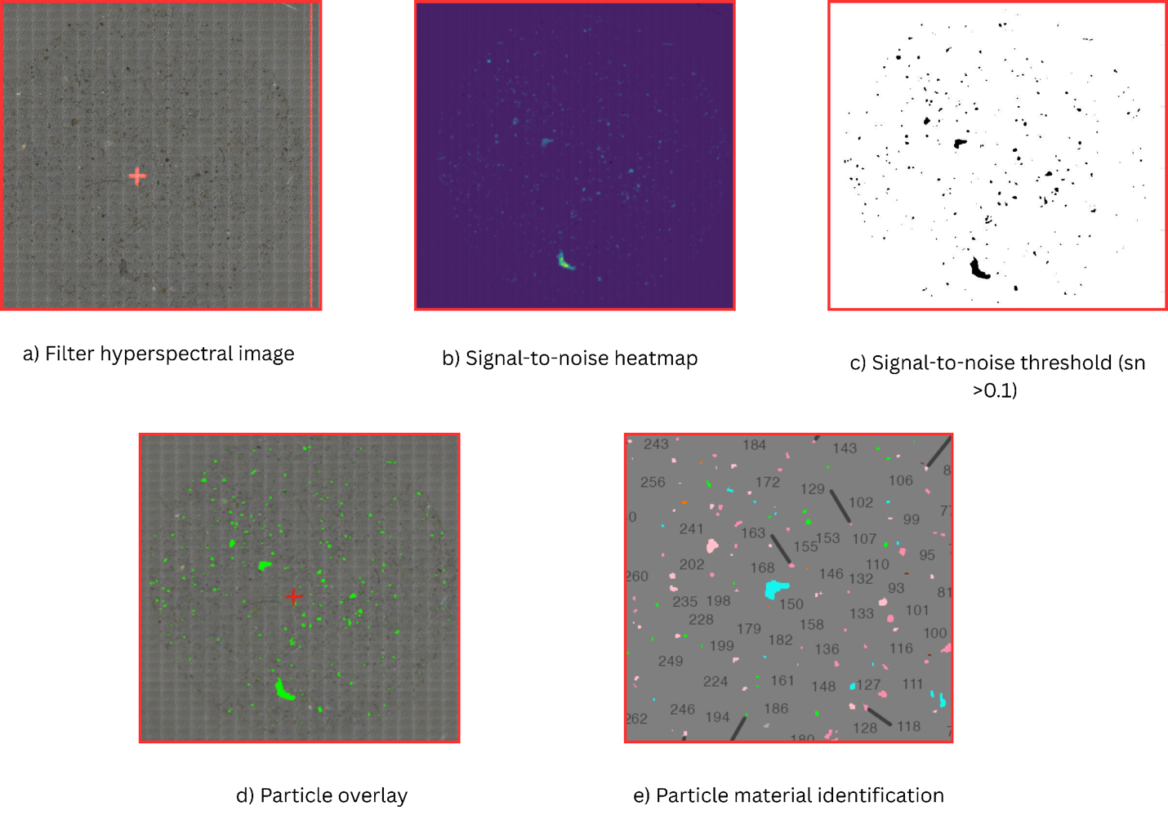
Fig. SX. Visal of μFTIR analytical workflow

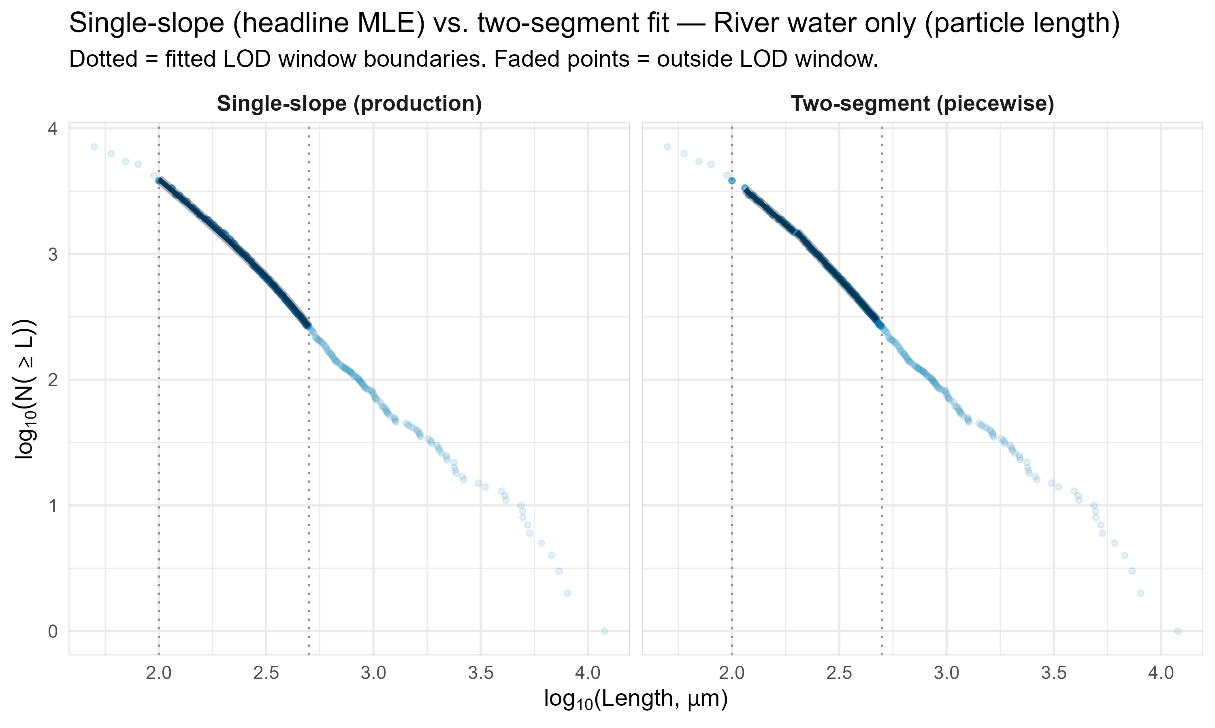
Figure SX. C-PSD power law fits for particle lengths for different matrices (colored points/lines) for single-slope (left panel) vs two-segment fits (right panel). Particle length (x-axis, um) and relative abundance (y-axis) are both log-transformed. Vertical dashed lines indicate LOD bounds for each of the fit regression lines.

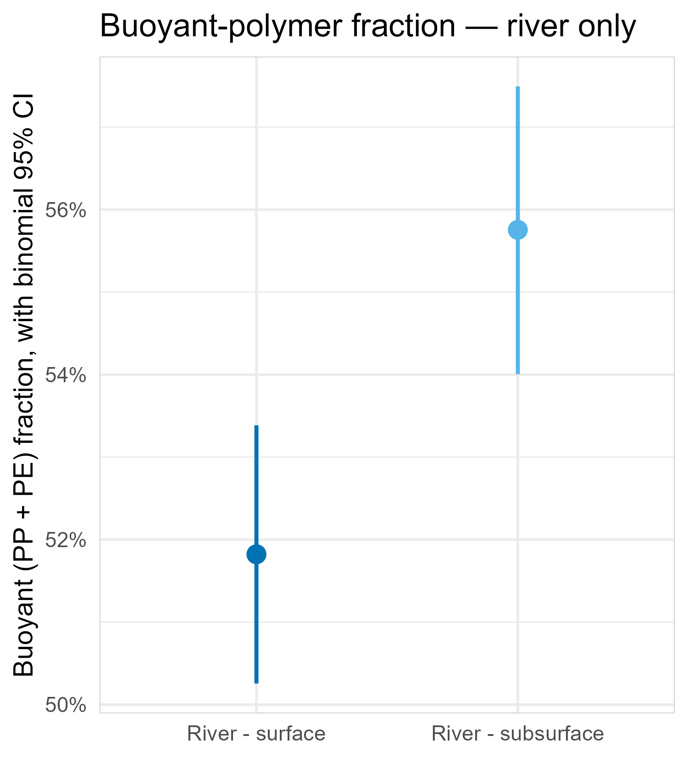
Figure SX. Buoyant-polymer (PP + PE) fraction by matrix and river depth stratum, with binomial 95% Cis.

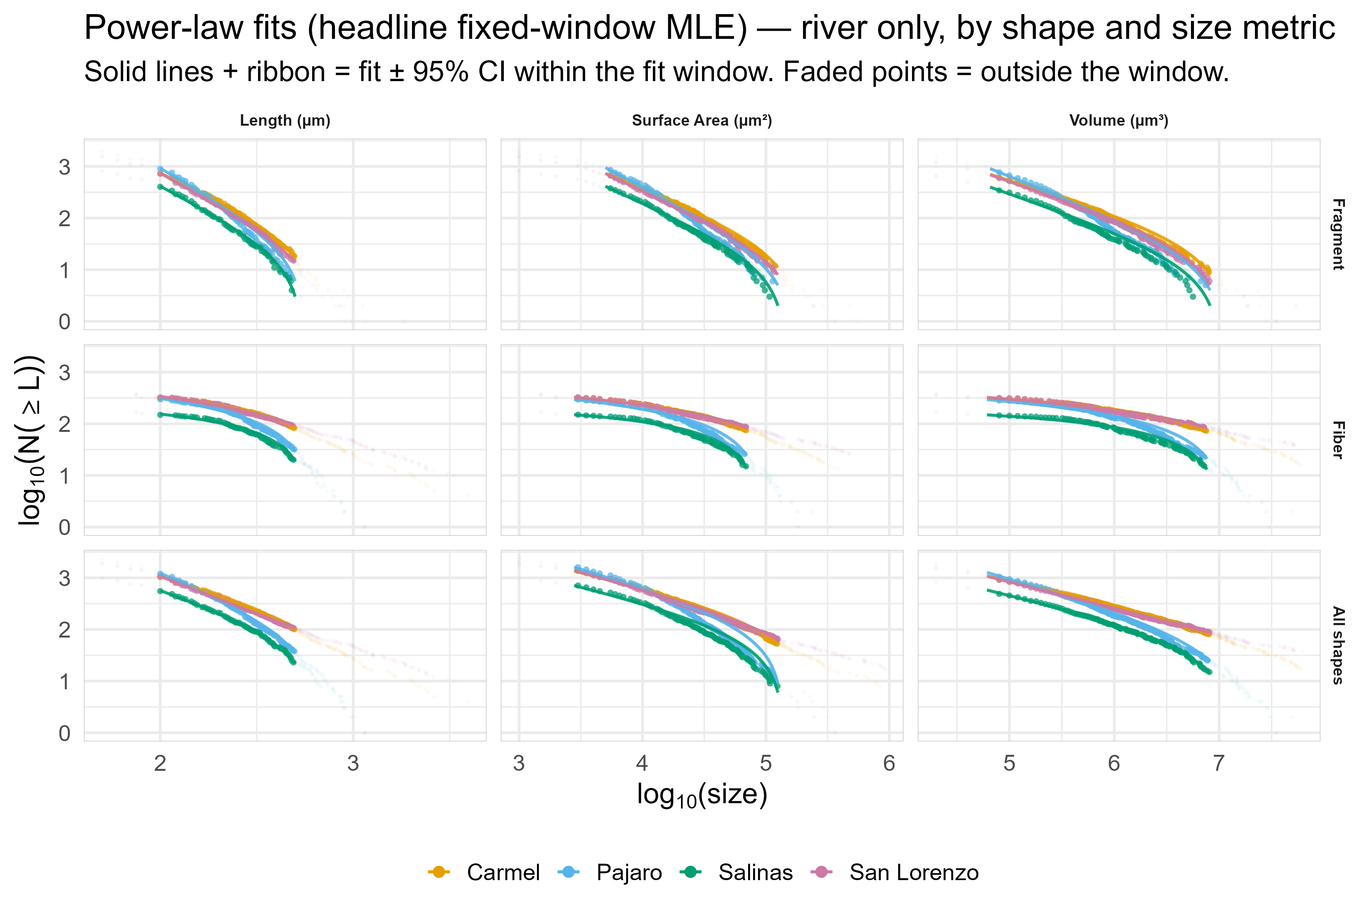
Figure SX. C-PSD power-law fits by matrix/location (color) x particle shape (y-axis facet) x particle attribute (x-axis facet) with fitted LOD windows (darker points and regression lines). Relative bin abundance is on the y-axis, with size on x-axis (units depend on each particle attribute). Both axes are log10 scale.

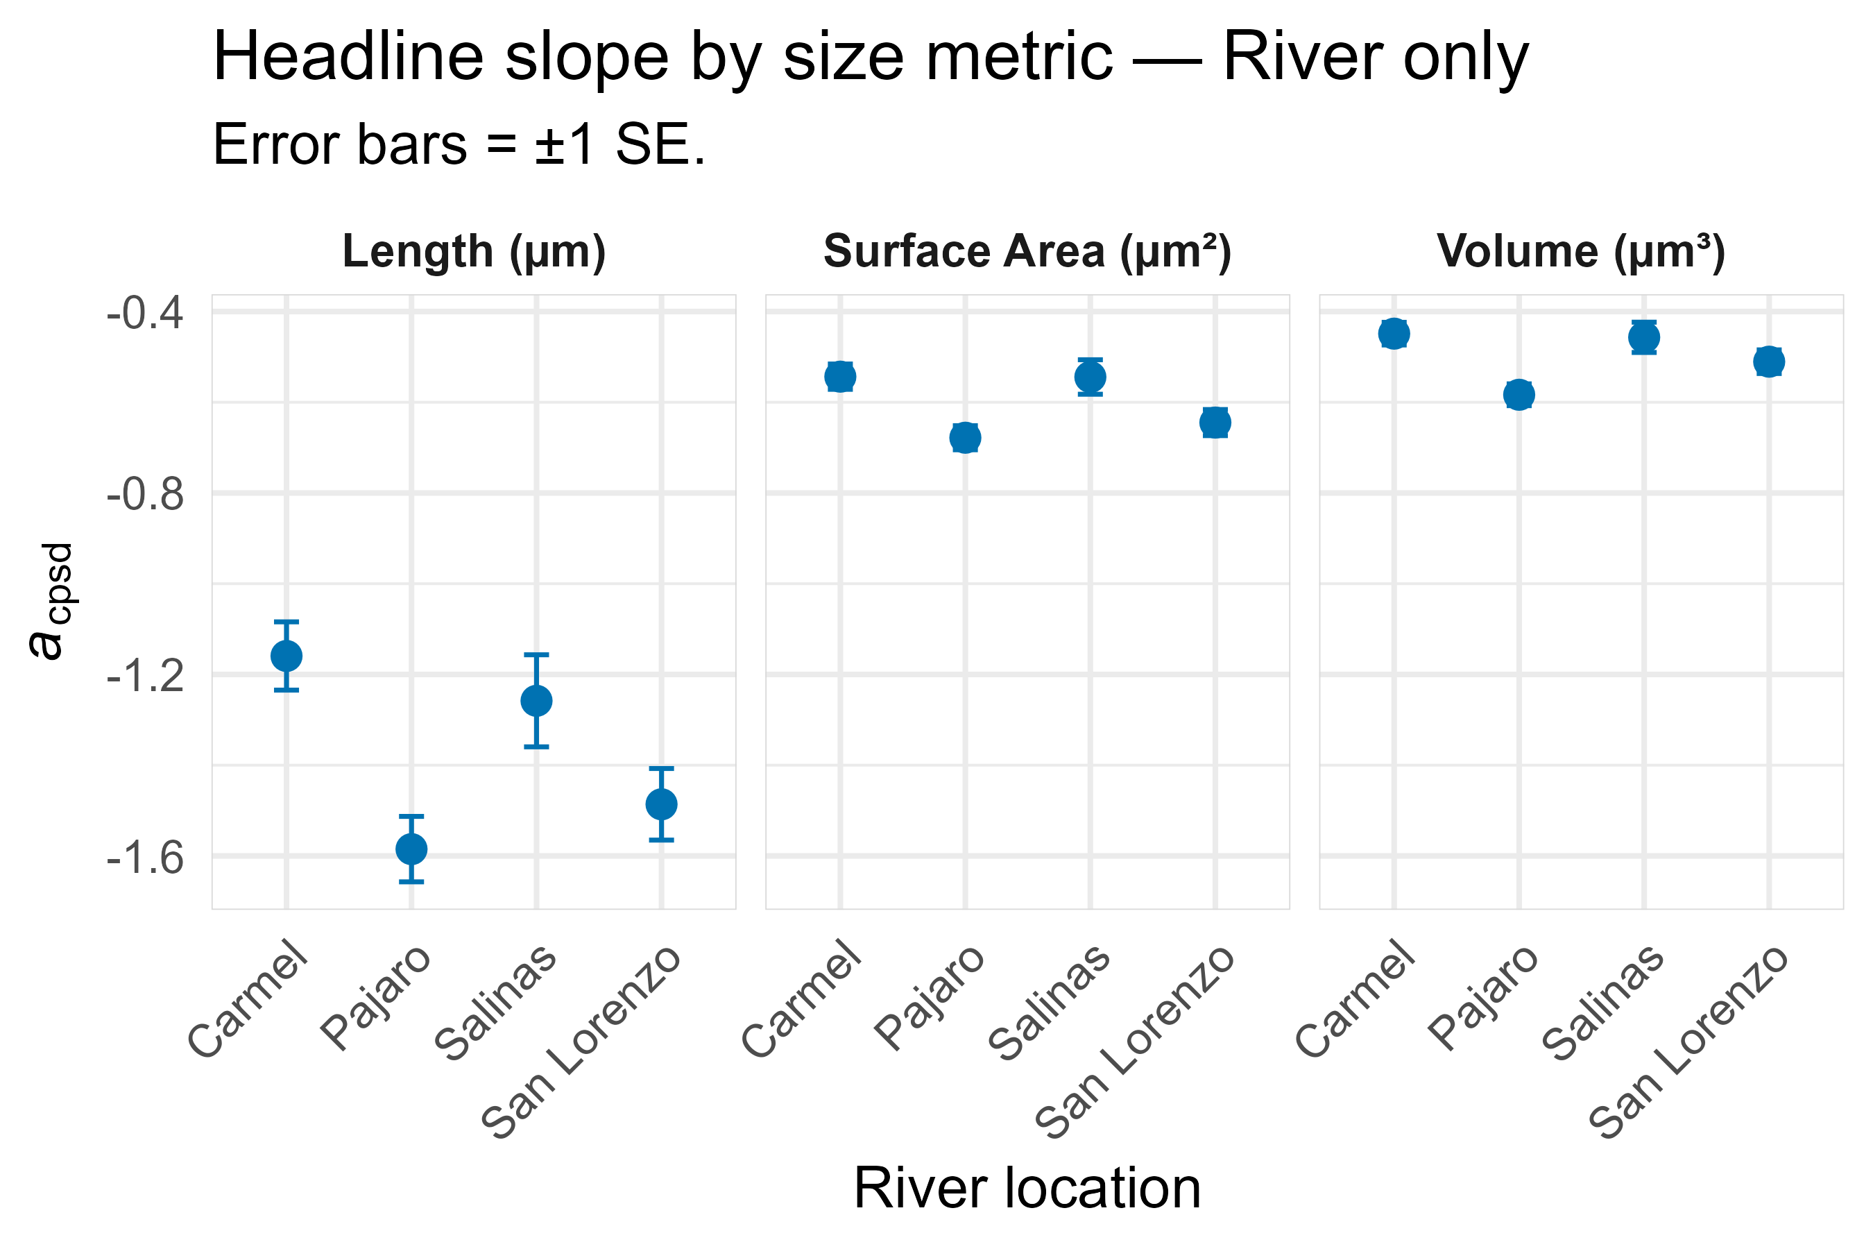
Figure SX. C-PSD power law fits by particle attribute (x-axis facet) by river (x-axis labels) with points representing median fit values and error bars corresponding to 95% CI’s. Only power law fits for all shapes combined are shown.

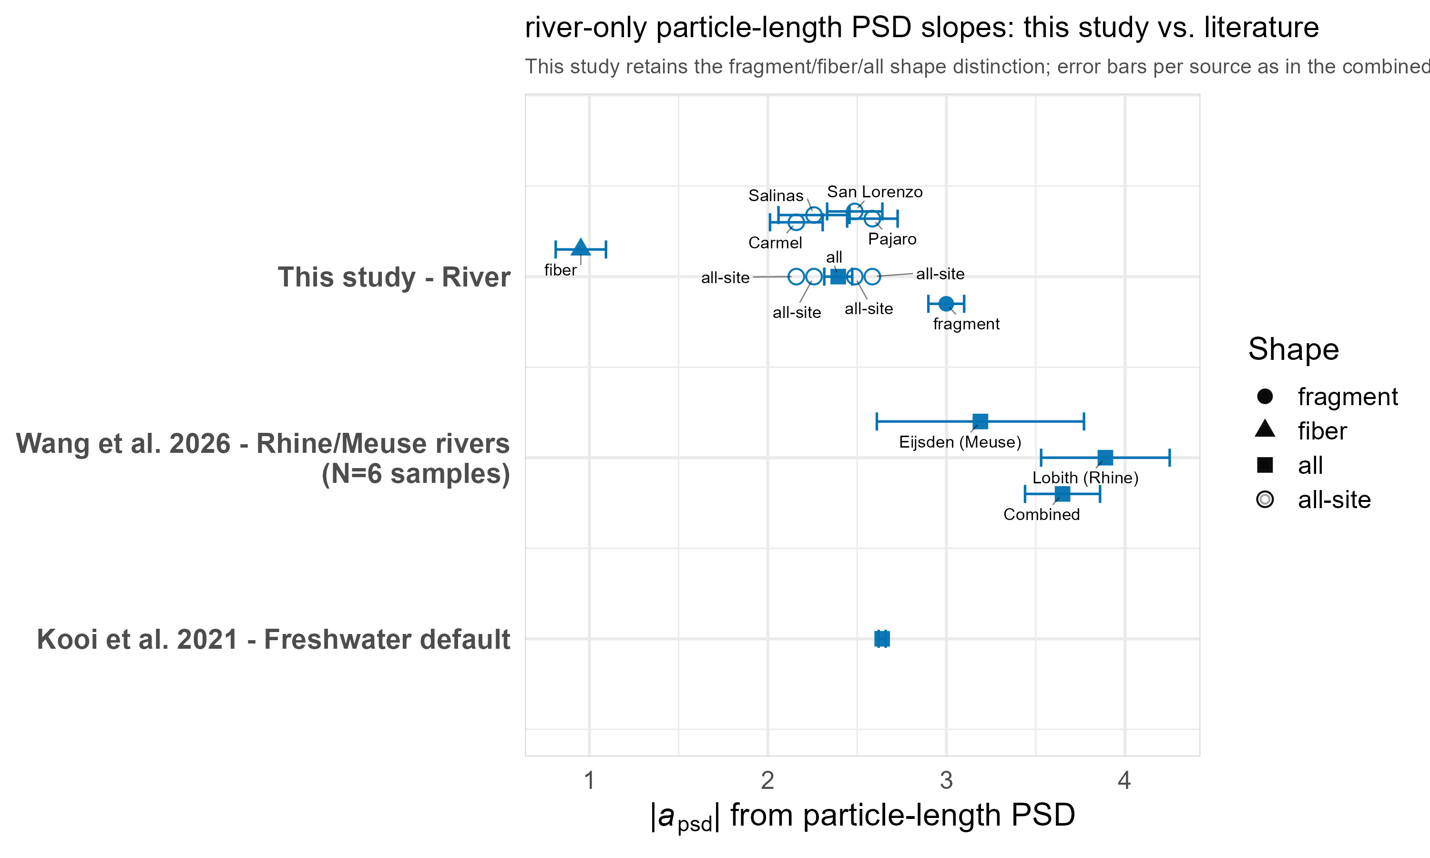
Figure SX. Particle-length PSD slopes (a), this study vs. published literature. Fits by shape (fragment/fiber/all) and by individual river sites are labels, with point estimates and corresponding 95% CIs. While refs.^{3,9,10} used different power law fitting algorithms to this study, ref.⁴ and the MPSizeBase data were all derived using same method in this study.
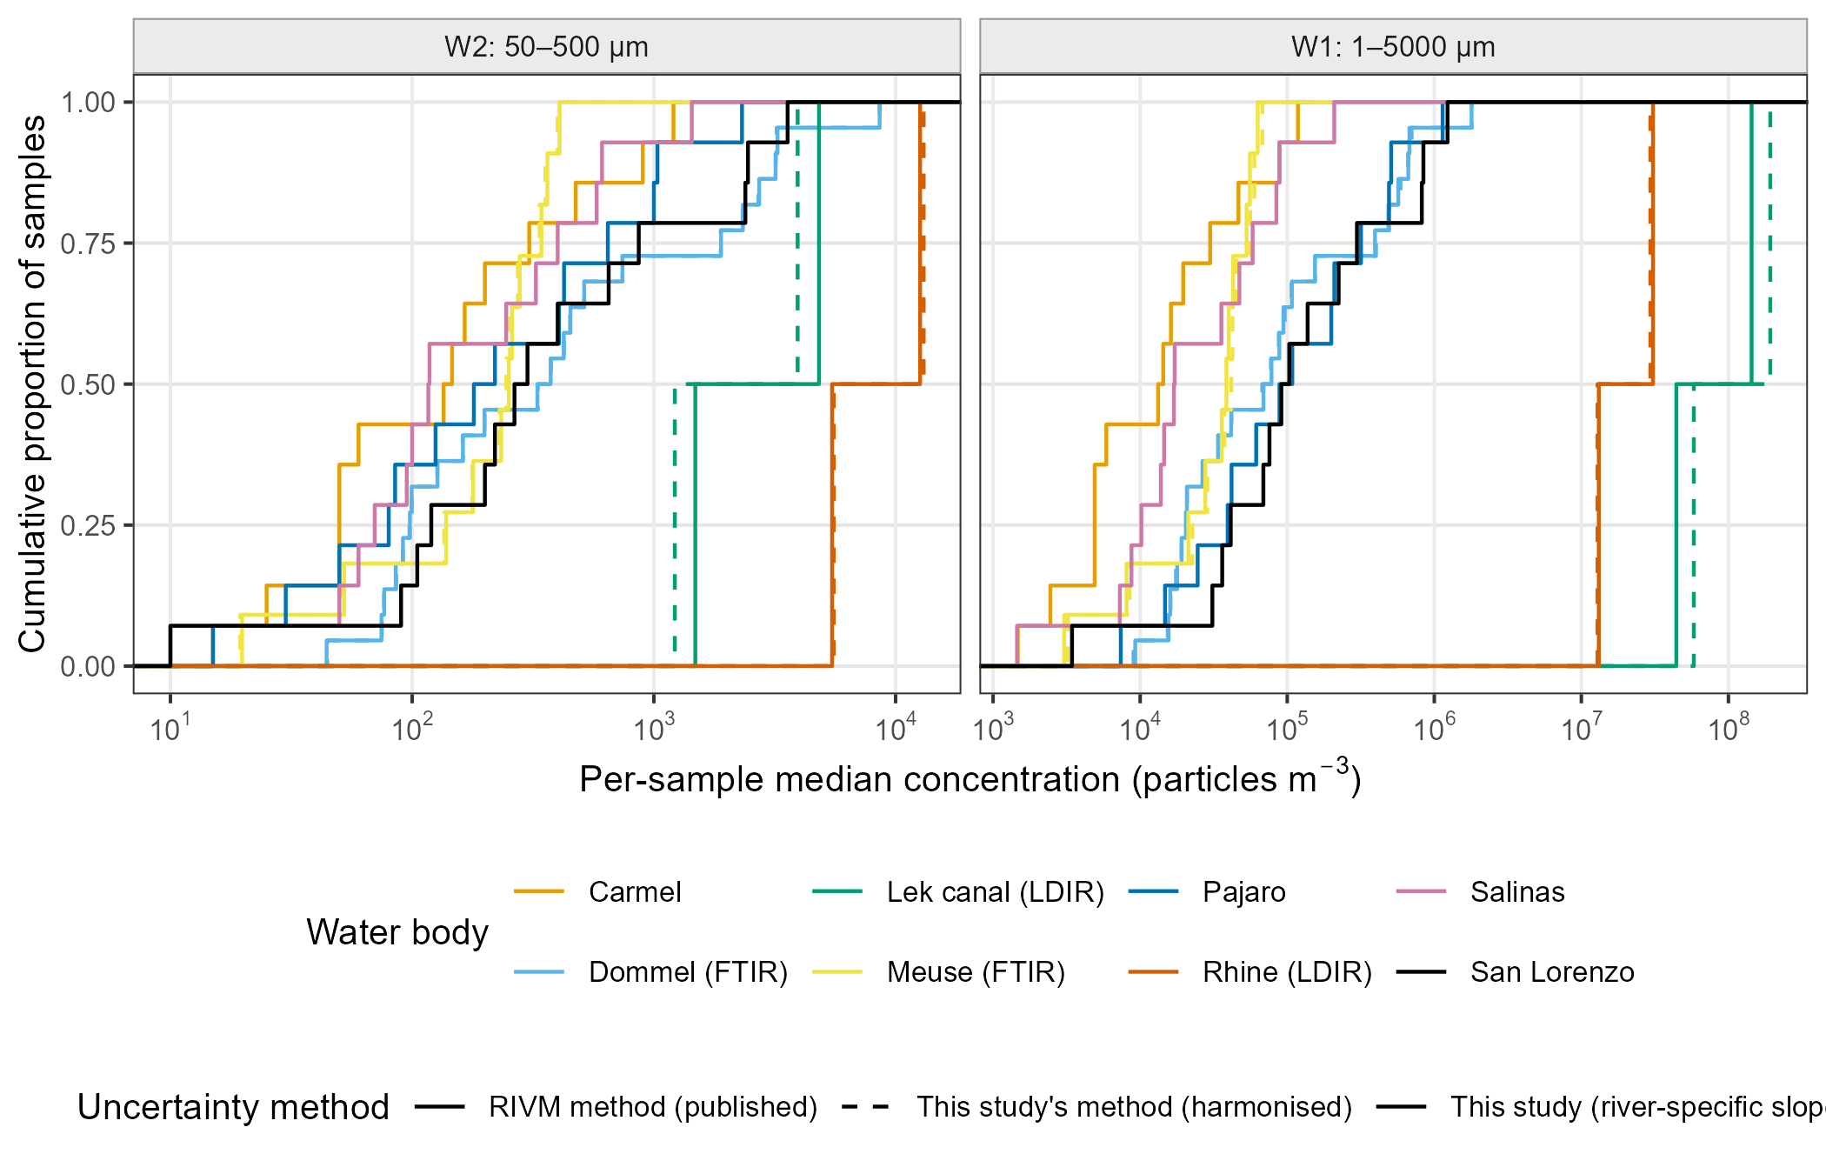
Figure S-A. Empirical distributions of rescaled concentrations, Dutch rivers vs this study. Empirical cumulative distributions of per-sample median rescaled concentrations by water body for W2 (50–500 µm) and W1 (1–5000 µm). Dutch: solid, RIVM uncertainty method; dashed, this study's harmonised method (truncated-normal slope with structural SD, fixed size limits); both reconstructed. This study: river-specific single slopes (W2 measured; W1 reconstructed). Slope convention: differential PSD slope a (dN/dL ∝ L^a); RIVM's positive PDF exponent α is converted as a = −α. Fitting methods differ: Dutch slopes are poweRlaw maximum-likelihood fits above an estimated xmin to particles ≤ 5000 µm, aggregated per water body and technique (ref. 11); this study's slopes are maximum-likelihood fits of a power law truncated at both ends of a fixed 100–500 µm window (the closest like-for-like estimator; the former C-PSD slopes were 0.45–0.9 steeper for three rivers). Systems differ: large perennial Dutch rivers and a canal (FTIR, refs. 12, 14; LDIR, ref. 13) versus discrete pumped samples from small, episodic Central Coast rivers (µFTIR). Dutch concentrations are study-reported totals (authors' blank and subsampling corrections), not recomputed from particles.
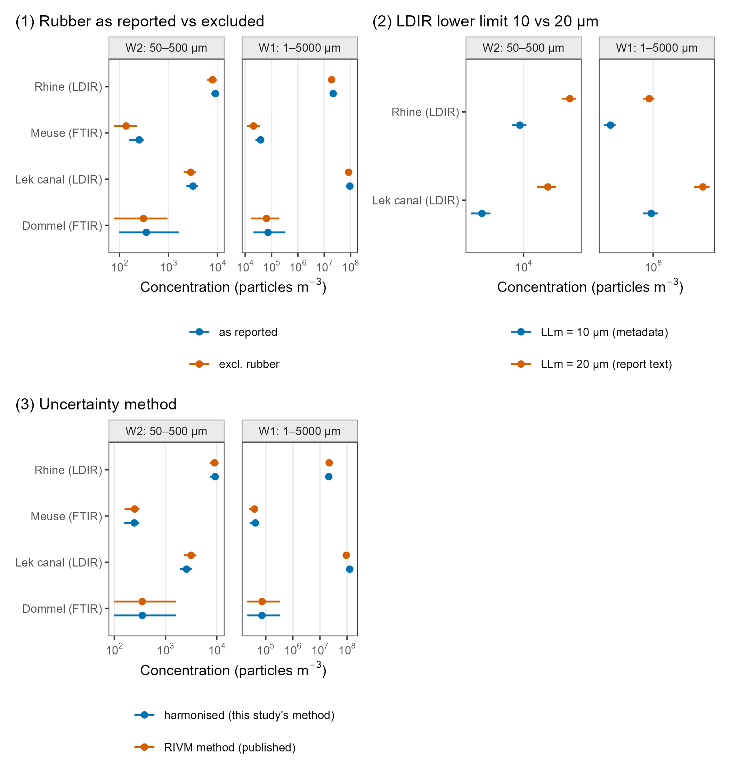
Figure S-B. Sensitivity of the Dutch-river benchmark. Sensitivity of Dutch water-body medians (points) and interquartile ranges (bars) of per-sample medians: (1) totals as reported versus excluding rubber (Mintenig: “Rubbers”; Mughini-Gras: isoprene; Mintenig 2025: EPDM rubber), since this study's polymer library has no rubber class; (2) LDIR lower size limit 10 µm (sample metadata) versus 20 µm (RIVM report text); (3) RIVM versus harmonised uncertainty method. All Dutch values reconstructed. Slope convention: differential PSD slope a (dN/dL ∝ L^a); RIVM's positive PDF exponent α is converted as a = −α. Fitting methods differ: Dutch slopes are poweRlaw maximum-likelihood fits above an estimated xmin to particles ≤ 5000 µm, aggregated per water body and technique (ref. 11); this study's slopes are maximum-likelihood fits of a power law truncated at both ends of a fixed 100–500 µm window (the closest like-for-like estimator; the former C-PSD slopes were 0.45–0.9 steeper for three rivers). Systems differ: large perennial Dutch rivers and a canal (FTIR, refs. 12, 14; LDIR, ref. 13) versus discrete pumped samples from small, episodic Central Coast rivers (µFTIR). Dutch concentrations are study-reported totals (authors' blank and subsampling corrections), not recomputed from particles.
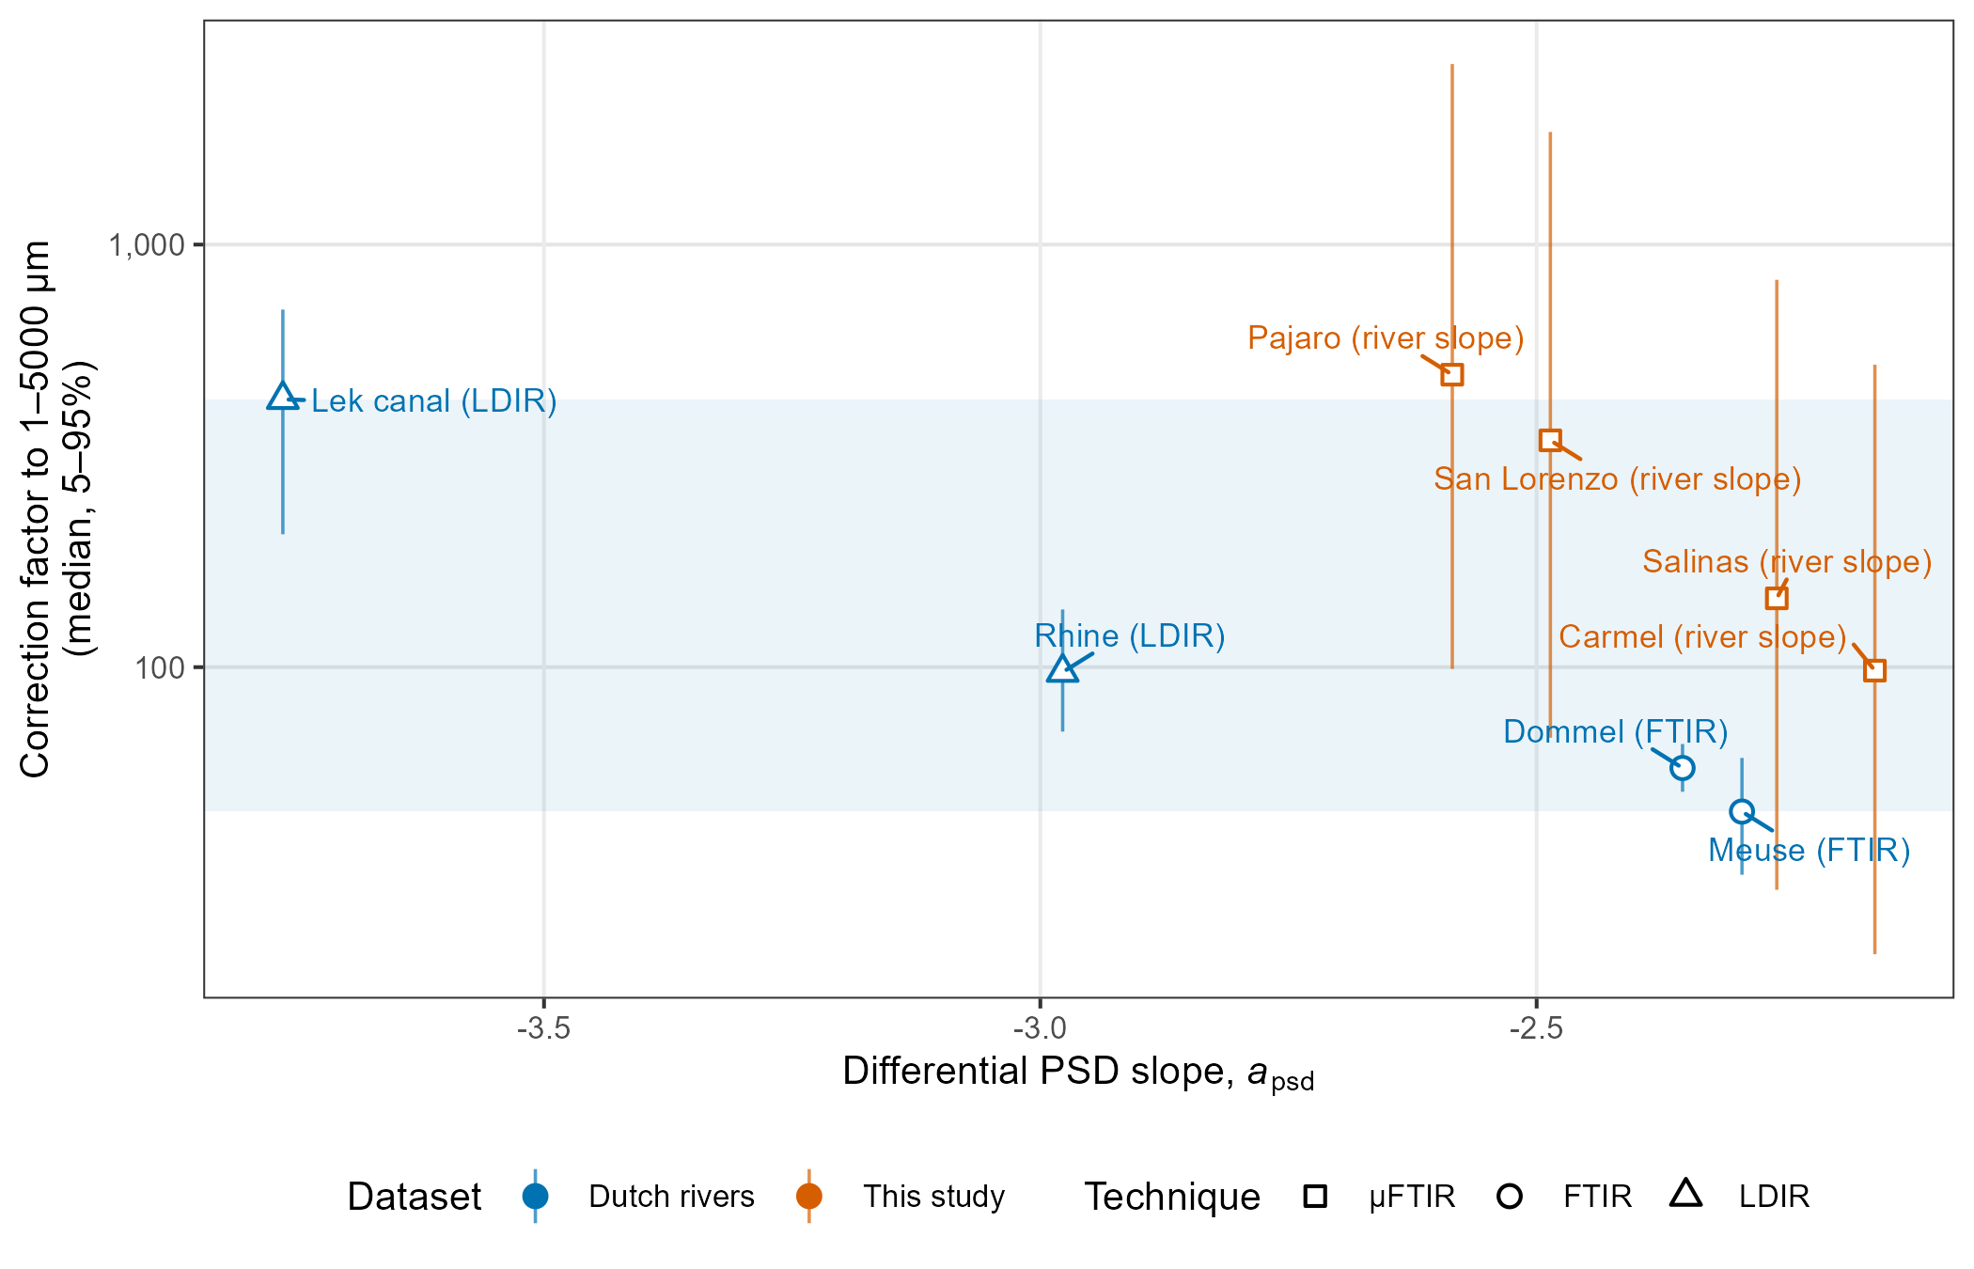
Figure S-C. Correction factors versus PSD slope. Correction factors to 1–5000 µm (median and 5–95%) versus differential slope. Dutch per-sample factors span 45–430 (RIVM report: 46–440; shaded band); this study's factors (50–500 µm sieve window) use each river's own slope and are labelled by river. All values reconstructed. Slope convention: differential PSD slope a (dN/dL ∝ L^a); RIVM's positive PDF exponent α is converted as a = −α. Fitting methods differ: Dutch slopes are poweRlaw maximum-likelihood fits above an estimated xmin to particles ≤ 5000 µm, aggregated per water body and technique (ref. 11); this study's slopes are maximum-likelihood fits of a power law truncated at both ends of a fixed 100–500 µm window (the closest like-for-like estimator; the former C-PSD slopes were 0.45–0.9 steeper for three rivers). Systems differ: large perennial Dutch rivers and a canal (FTIR, refs. 12, 14; LDIR, ref. 13) versus discrete pumped samples from small, episodic Central Coast rivers (µFTIR). Dutch concentrations are study-reported totals (authors' blank and subsampling corrections), not recomputed from particles.

Supplemental Tables

Polymer type | Total particles | Percent of plastic particles
poly(propylene) | 1,298 | 34.4%
poly(acrylamide/amid)s | 1,103 | 29.2%
poly(ethylene) | 456 | 12.1%
polystyrenes (polyphenylethylenes, -methylstyrene) | 334 | 8.8%
poly(esters/ethers/diglycidylethers/terephthalates)s | 176 | 4.7%
polyacrylates (propenoates) | 130 | 3.4%
polyurethanes (isocyanates) | 67 | 1.8%
polyhaloolefins (vinylhalides) | 60 | 1.6%
polymethacrylates | 31 | 0.8%
polysiloxanes | 26 | 0.7%
poly(tetrafluoroethylene) | 25 | 0.7%
polyvinylesters | 24 | 0.6%
cellulose derivatives (ether cellulose) | 16 | 0.4%
ethylene-vinyl acetate | 6 | 0.2%
polyhydroxy(meth)acrylates | 6 | 0.2%
polyvinylalcohols | 6 | 0.2%
polyimides | 4 | 0.1%
acrylonitrile butadiene styrene (abs) | 3 | 0.1%
polyacrylonitriles (nitriles) | 2 | 0.1%
poly(ether)ketones (polyketones) | 1 | 0.0%
polycarbonates | 1 | 0.0%
polyethersulfones (polysulfone) | 1 | 0.0%
polyvinylethers | 1 | 0.0%

Table S1. Polymer types from all river samples. Count of all 23 polymer types of particles 50-500 μm as identified by μFTIR.

Table SX. Lab blank levels from Moore Institute (smaller size class)

group | mippr_id | count
MBMS_01 | MIPPR_MBMS_PrcdrlBlnk_7Feb24 | 12
MBMS_02 | MIPPR_PB_23JUL24 | 1
MBMS_03 | MIPPR_PB_08JAN25 | 2
MBMS_06A | MIPPR_PB_30JAN25 | 0
MBMS_06B | MIPPR_PB_7FEB25 | 9
MBMS_06C | MIPPR_PB_13MAR25 | 10
MBMS_07A | MIPPR_PB_05AUG25 | 2
MBMS_07B | MIPPR_PB_15AUG25 | 4
MBMS_07C | MIPPR_PB_27AUG25 | 2
MBMS_11A | MIPPR_PB_24APR26 | 0
MBMS_11B | MIPPR_PB_29APR26 | 8
MBMS_11C | MIPPR_PB_06MAY26 | 19

Table SX. Lab blanks from Hopkins Marine Station (larger size class): 58 lab blanks (one for every day of labwork), median of two fibers per blank.
Date | Total particles | Fibers | Fragments | Films | Nurdles | Foam
8/12/2024 | 0 | 0 | 0 | 0 | 0 | 0
8/16/2024 | 3 | 3 | 0 | 0 | 0 | 0
8/25/2024 | 1 | 1 | 0 | 0 | 0 | 0
4/26/2024 | 0 | 0 | 0 | 0 | 0 | 0
9/2/2024 | 0 | 0 | 0 | 0 | 0 | 0
6/28/2024 | 4 | 4 | 0 | 0 | 0 | 0
9/5/2024 | 2 | 2 | 0 | 0 | 0 | 0
9/26/2024 | 2 | 2 | 0 | 0 | 0 | 0
9/28/2024 | 0 | 0 | 0 | 0 | 0 | 0
4/5/2024 | 1 | 1 | 0 | 0 | 0 | 0
4/10/2024 | 2 | 2 | 0 | 0 | 0 | 0
11/17/2024 | 0 | 0 | 0 | 0 | 0 | 0
11/21/2024 | 1 | 1 | 0 | 0 | 0 | 0
12/12/2024 | 0 | 0 | 0 | 0 | 0 | 0
1/14/2025 | 3 | 3 | 0 | 0 | 0 | 0
1/27/2025 | 3 | 3 | 0 | 0 | 0 | 0
2/17/2025 | 2 | 2 | 0 | 0 | 0 | 0
2/24/2025 | 3 | 2 | 0 | 1 | 0 | 0
2/27/2025 | 3 | 3 | 0 | 0 | 0 | 0
3/3/2025 | 5 | 3 | 2 | 0 | 0 | 0
3/6/2025 | 6 | 4 | 2 | 0 | 0 | 0
3/10/2025 | 5 | 4 | 1 | 0 | 0 | 0
3/17/2025 | 5 | 4 | 1 | 0 | 0 | 0
3/20/2025 | 3 | 3 | 0 | 0 | 0 | 0
3/24/2025 | 3 | 3 | 0 | 0 | 0 | 0
3/27/2025 | 2 | 2 | 0 | 0 | 0 | 0
3/31/2025 | 2 | 2 | 0 | 0 | 0 | 0
4/7/2025 | 3 | 3 | 0 | 0 | 0 | 0
4/10/2025 | 2 | 2 | 0 | 0 | 0 | 0
4/17/2025 | 3 | 3 | 0 | 0 | 0 | 0
4/21/2025 | 2 | 2 | 0 | 0 | 0 | 0
4/24/2025 | 3 | 3 | 0 | 0 | 0 | 0
4/28/2025 | 1 | 1 | 0 | 0 | 0 | 0
5/5/2025 | 0 | 0 | 0 | 0 | 0 | 0
5/8/2025 | 2 | 2 | 0 | 0 | 0 | 0
5/13/2025 | 1 | 1 | 0 | 0 | 0 | 0
5/14/2025 | 2 | 2 | 0 | 0 | 0 | 0
5/19/2025 | 1 | 1 | 0 | 0 | 0 | 0
5/20/2025 | 9 | 9 | 0 | 0 | 0 | 0
5/27/2025 | 6 | 6 | 0 | 0 | 0 | 0
6/10/2025 | 5 | 5 | 0 | 0 | 0 | 0
6/11/2025 | 2 | 2 | 0 | 0 | 0 | 0
6/17/2025 | 1 | 1 | 0 | 0 | 0 | 0
6/18/2025 | 4 | 3 | 1 | 0 | 0 | 0
6/19/2025 | 1 | 1 | 0 | 0 | 0 | 0
7/1/2025 | 9 | 6 | 3 | 0 | 0 | 0
7/3/2025 | 2 | 2 | 0 | 0 | 0 | 0
7/8/2025 | 5 | 4 | 1 | 0 | 0 | 0
7/10/2025 | 9 | 5 | 4 | 0 | 0 | 0
7/15/2025 | 2 | 2 | 0 | 0 | 0 | 0
7/17/2025 | 6 | 6 | 0 | 0 | 0 | 0
7/22/2025 | 2 | 2 | 0 | 0 | 0 | 0
7/24/2025 | 1 | 1 | 0 | 0 | 0 | 0

Table S-A. Dutch river and Monterey Bay sample sets included in the concentration benchmark. Numbers in parentheses are SI reference numbers. a, differential slope (Dutch: RIVM bootstrap 95% CI, as published; this study: pooled fit ±1.96 SE). Fit window: Dutch, estimated x_{min} (fit extends to 5000 µm); this study, LOD window. Reported, range of study-reported totals (measured). Rescaled columns: median of per-sample medians [lowest per-sample 5th – highest per-sample 95th percentile], particles m⁻³; Dutch values reconstructed with the RIVM method, this study’s with the pooled single slope (W2 measured, W1 reconstructed).
Study | Water body | n | Technique | Measured range (µm) | a [95% CI] | Fit window | Reported (particles m⁻³) | W2 50–500 µm | W1 1–5000 µm
Mintenig et al. 2020 (12) | Dommel | 18 | FTIR | 20–5000 | −2.35 [−2.40, −2.31] | xmin 170 µm | 160–12,000 | 180 [40–3,500] | 38,000 [8,200–7.6 × 10⁵]
Mintenig et al. 2020 (12) | Meuse | 11 | FTIR | 20–5000 | −2.29 [−2.41, −2.11] | xmin 268 µm | 67–1,400 | 250 [18–460] | 39,000 [2,200–83,000]
Mintenig et al. 2025 (14) | Dommel | 4 | FTIR | 20–5000 | −2.35 [−2.40, −2.31] | xmin 170 µm | 1,400–31,000 | 3,000 [340–9,400] | 6.2 × 10⁵ [69,000–2.0 × 10⁶]
Mughini-Gras et al. 2021 (13) | Lek canal | 2 | LDIR | 10–500 | −3.76 [−3.89, −3.18] | xmin 62 µm | 1.0 × 10⁵–3.3 × 10⁵ | 3,200 [1,000–8,000] | 9.4 × 10⁷ [2.1 × 10⁷–2.3 × 10⁸]
Mughini-Gras et al. 2021 (13) | Rhine | 2 | LDIR | 10–500 | −2.98 [−3.19, −2.80] | xmin 67 µm | 1.4 × 10⁵–3.1 × 10⁵ | 9,000 [4,200–16,000] | 2.2 × 10⁷ [9.5 × 10⁶–4.3 × 10⁷]
This study | Carmel | 14 | µFTIR | 50–500 | −2.16 [−2.31, −2.01] | window 100–500 µm | 15–1,200 | 140 [15–1,200] | 14,000 [310–6.3 × 10⁵]
This study | Pajaro | 14 | µFTIR | 50–500 | −2.58 [−2.73, −2.44] | window 100–500 µm | 15–2,300 | 200 [15–2,300] | 98,000 [1,500–6.2 × 10⁶]
This study | Salinas | 14 | µFTIR | 50–500 | −2.26 [−2.46, −2.06] | window 100–500 µm | 10–1,400 | 120 [10–1,400] | 17,000 [300–1.2 × 10⁶]
This study | San Lorenzo | 14 | µFTIR | 50–500 | −2.49 [−2.64, −2.33] | window 100–500 µm | 10–3,600 | 280 [10–3,600] | 97,000 [680–6.6 × 10⁶]

References
(1) Cole, M. A Novel Method for Preparing Microplastic Fibers. Sci Rep 2016, 6 (1), 34519. https://doi.org/10.1038/srep34519.
(2) Hidalgo-Ruz, V.; Gutow, L.; Thompson, R. C.; Thiel, M. Microplastics in the Marine Environment: A Review of the Methods Used for Identification and Quantification. Environ. Sci. Technol. 2012, 46 (6), 3060–3075. https://doi.org/10.1021/es2031505.
(3) Kooi, M.; Primpke, S.; Mintenig, S. M.; Lorenz, C.; Gerdts, G.; Koelmans, A. A. Characterizing the Multidimensionality of Microplastics across Environmental Compartments. Water Research 2021, 202 (July). https://doi.org/10.1016/j.watres.2021.117429.
(4) Segur, T.; Hough, I.; Dobiasova, N.; Voisin, D.; Richon, C.; Angot, H.; Thomas, J. L.; Sonke, J. E. Using the Power Law Size Distribution to Extrapolate and Compare Microplastic Number and Mass Concentrations in Environmental Media. Micropl.&Nanopl. 2026, 6 (1), 45. https://doi.org/10.1186/s43591-026-00205-5.
(5) Koelmans, A. A.; Mohamed Nor, N. H.; Hermsen, E.; Kooi, M.; Mintenig, S. M.; De France, J. Microplastics in Freshwaters and Drinking Water: Critical Review and Assessment of Data Quality. Water Research 2019, 155, 410–422. https://doi.org/10.1016/j.watres.2019.02.054.
(6) Hoffman, M. J.; DiBenedetto, M. H. How Size-Dependent Settling Can Both Bias and Inform Microplastics Observations. Environ. Res. Commun. 2026, 8 (6), 065061. https://doi.org/10.1088/2515-7620/ae76df.
(7) Symonds, M. R. E.; Moussalli, A. A Brief Guide to Model Selection, Multimodel Inference and Model Averaging in Behavioural Ecology Using Akaike’s Information Criterion. Behavioral Ecology and Sociobiology 2011, 65 (1), 13–21. https://doi.org/10.1007/s00265-010-1037-6.
(8) Thomas, A.; Marchand, J.; Schwoerer, G. D.; Minor, E. C.; Maurer-Jones, M. A. Size Distributions of Microplastics in the St Louis Estuary and Western Lake Superior. Environ. Sci. Technol. 2024, 58 (19), 8480–8489. https://doi.org/10.1021/acs.est.3c10776.
(9) Wang, S.; Mintenig, S. M.; Wu, J.; Koelmans, A. A. Implications of Method- and Instrument-Based Size Detection Limits in μFTIR-Based Microplastic Analysis. Talanta 2026, 296, 128417. https://doi.org/10.1016/j.talanta.2025.128417.
(10) Zhao, B.; Richardson, R. E.; Huang, Y.; You, F. Physically-Based Mesh Selectivity Correction Model for Standardized Microplastic Abundance Estimates in Aquatic Environment. Water Research 2026, 299, 125833. https://doi.org/10.1016/j.watres.2026.125833.

(11) Quik, J. T. K.; van Breemen, P.; Hids, A. R.; van Loon, S.; Mintenig, S. M.; Koelmans, A. A. Screening Level Ecological Risk Assessment of Microplastics in Dutch Surface Waters; RIVM Letter Report 2026-0069; National Institute for Public Health and the Environment (RIVM): Bilthoven, 2026. https://doi.org/10.21945/RIVM-2026-0069. Data and code: https://github.com/rivm-syso/MicroplasticsERA_water.
(12) Mintenig, S. M.; Kooi, M.; Erich, M. W.; Primpke, S.; Redondo-Hasselerharm, P. E.; Dekker, S. C.; Koelmans, A. A.; van Wezel, A. P. A Systems Approach to Understand Microplastic Occurrence and Variability in Dutch Riverine Surface Waters. Water Research 2020, 176, 115723. https://doi.org/10.1016/j.watres.2020.115723.
(13) Mughini-Gras, L.; van der Plaats, R. Q. J.; van der Wielen, P. W. J. J.; Bauerlein, P. S.; de Roda Husman, A. M. Riverine Microplastic and Microbial Community Compositions: A Field Study in the Netherlands. Water Research 2021, 192, 116852. https://doi.org/10.1016/j.watres.2021.116852.
(14) Mintenig, S. M.; Hunnestad, A.; Koelmans, A. A. Microplastics in het oppervlaktewater van de Dommel; Wageningen University & Research, 2025.

